Here’s your shortened version (~800 words) with the same tone, structure, and simplicity, minimal stylistic changes, and all placeholders kept:

COMIC STOCK — GUERILLA TEST REPORT
Phase 1 Checkout Paper Mockup
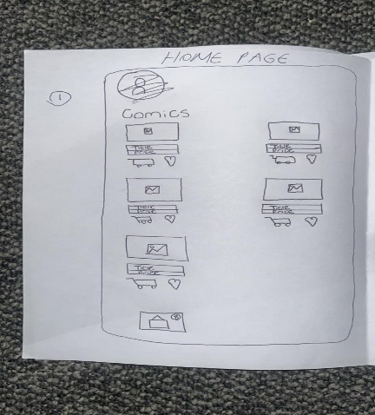 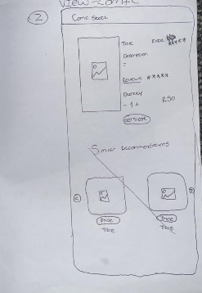
WHAT WE DID
We took our paper mockup of the Comic Stock checkout flow to five people and asked each of them to walk through buying a comic book from start to finish. We watched where they got stuck, where they hesitated, and what they assumed buttons would do. Two of the testers were technical (a product designer and a developer); the other three were normal end users who would actually buy a comic on the site.
The goal was simple: find out what works, what does not, and use that to improve the digitized mockup.
WHO WE SPOKE TO
- Technical User 1 — product designer, focused on the quality of the mockup.
- Technical User 2 — developer, focused on UI consistency and detail.
- End User 1 — first-time visitor, completed the full purchase flow.
- End User 2 and 3 — tested together, casual buyers.
- End User 4 — experienced online shopper.
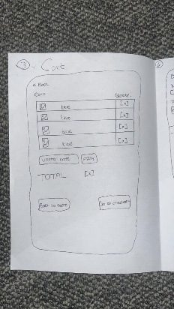
THE BIG THEMES
1. THE CART NEEDS TO BE EDITABLE
Every end user tried to change something in the cart and could not. They wanted to increase quantity, remove items, or clear the cart. The cart being read-only frustrated all of them. This was the most consistent feedback.
2. THE CHECKOUT ASKS FOR TOO MUCH
Users felt that filling in delivery details, billing info and preferences during checkout is stressful. One user said that when you are about to spend money, you do not want extra effort.
The expectation is that this information should be saved when the account is created and then selected quickly at checkout.
3. THE CONFIRMATION PAGE REPEATS ITSELF
Users said the confirmation screen repeated information they had already seen multiple times. They preferred a short confirmation with an order number, with the full receipt sent by email.
4. UNCLEAR HOW TO GET FROM HOME TO CART
End User 1 added a comic to the cart but could not find how to open it. The cart icon was not obvious. Technical User 2 also pointed this out and said the icon was unclear and poorly placed.
5. WE ARE OVERPROMISING FEATURES
Both technical and end users pointed at features like wishlists, recommendations and reviews and questioned why they were included. The advice was to focus on the basics first and add extra features later.
6. MISSING DETAILS THAT MATTER
- No description of the comic on the listing page. Users wanted a short blurb.
- No VAT shown on prices, which is required in South Africa.
- No shipping cost shown until late in the process.
- Apple Pay was assumed without options for Android users.
7. THE FLOW ITSELF IS FINE
No one said the order of steps was wrong. One user said the flow follows normal e-commerce patterns. The structure works. The issues are in the details and how each step is handled.
8. MOCKUP-QUALITY FEEDBACK
The product designer said the mockup needed more context on each screen. Labels and step indicators would make testing clearer. Future tests should also have clearer goals.
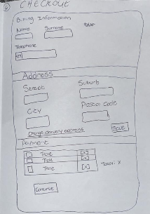 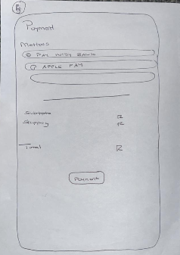 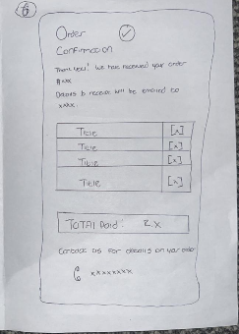
COMMONALITIES — WHERE EVERYONE AGREED
Some feedback came up more than once, which made it more reliable:
- Cart needs editing — mentioned by all end users.
- Confirmation page repeats too much — mentioned by most users.
- Cart navigation is unclear — mentioned by a user and the developer.
- Too many extra features — mentioned by several testers.
- The flow works — confirmed by most users.
- Entering details from scratch is frustrating — widely agreed.
THE OVERALL SENTIMENT
The feeling was positive but honest. Nobody said the idea was wrong and nobody got completely lost. The checkout flow makes sense.
What users focused on were the small details, missing elements, and features that were not needed.
In simple terms: the structure is right, but the details need work.
WHAT WE CHANGED IN THE DIGITIZED MOCKUP
LINK: https://miro.com/app/board/uXjVGo-XZxM=/?moveToWidget=3458764666785043794&cot=14
Based on the feedback:
- Added quantity controls, remove option, and clear cart.
- Improved the cart icon and its placement.
- Added short descriptions to comic listings.
- Used saved address and payment details at checkout, with edit options.
- Simplified the confirmation page to a short message and order number.
- Removed wishlist, reviews and recommendations for Phase 1.
- Showed VAT and shipping costs earlier in the cart.
- Replaced Apple Pay with broader payment options (card, EFT, mobile).
WHAT WE DID NOT CHANGE — AND WHY
- The order of the checkout steps stays the same because users found it familiar.
- The account-based model stays. Users expected saved details, which supports this decision.
CLOSING Remarks
The biggest takeaway is that the checkout structure is solid. The problems are in the details, not the foundation.

